**1. Execute-Process**

**What it does:** This is a fundamental PSADT function used to run any executable file or command. It's the go-to command for launching installers, custom scripts, or any other program that needs to be executed as part of your deployment. It's highly flexible and allows you to specify command-line arguments, control the process's waiting behavior, and capture the exit code.

**When to use it:** Use Execute-Process for standard .exe installers, batch files (.bat), or any non-MSI process that needs to be run.

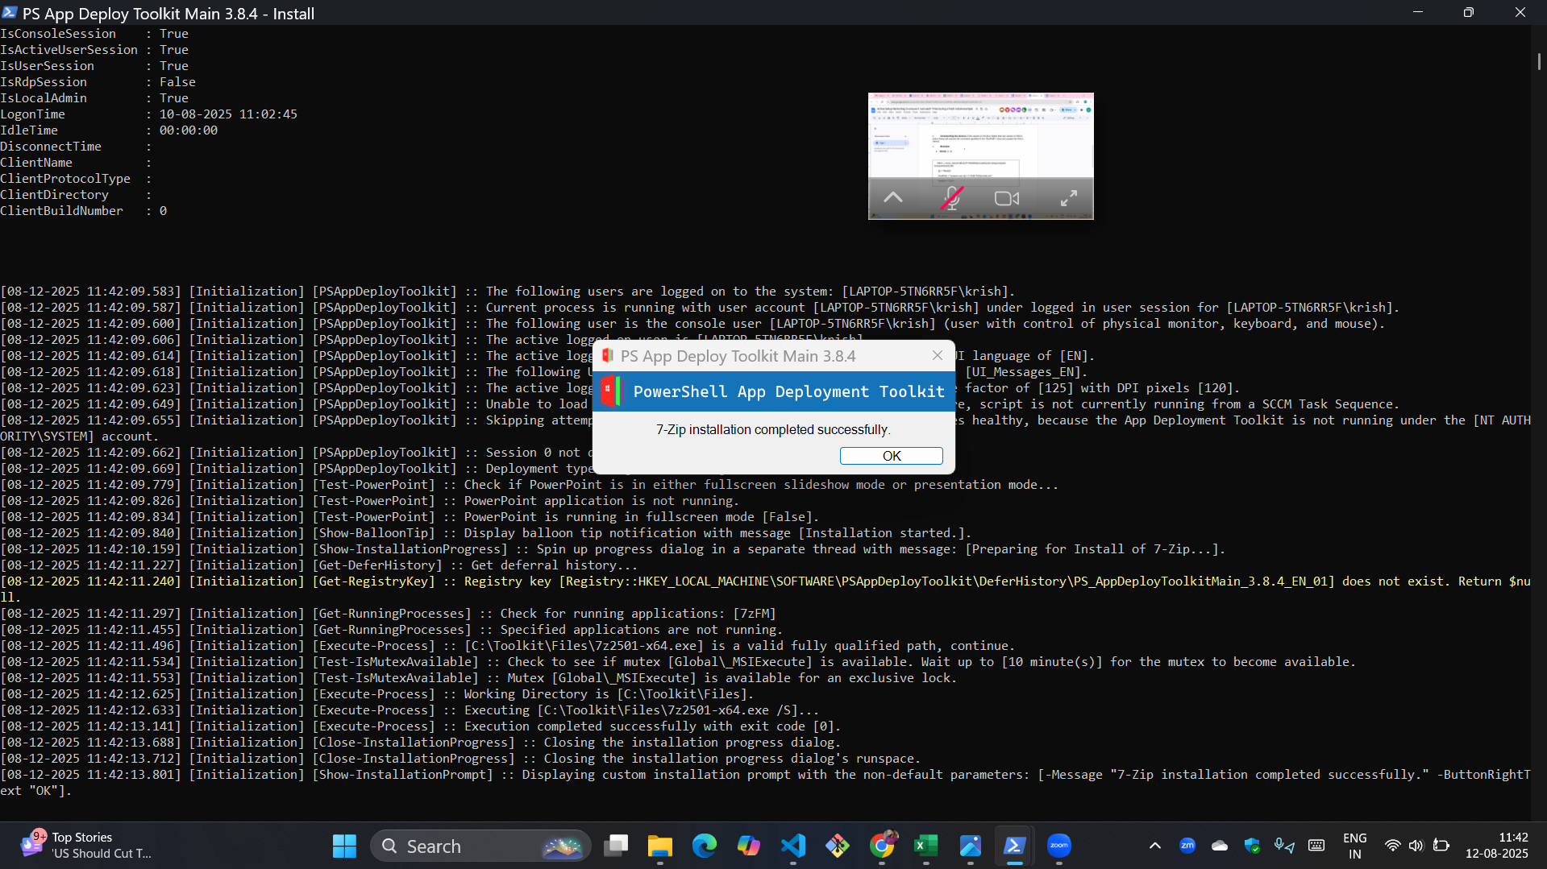**Practical Screenshots Section :**

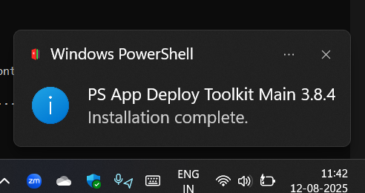



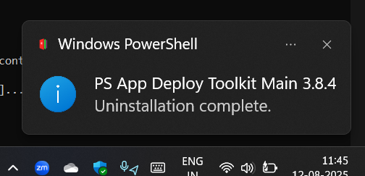

**2. Execute-MSI**

**What it does:** This function is the dedicated way to handle Microsoft Installer (.msi) files. It's a more reliable and streamlined alternative to manually running msiexec.exe. It automatically handles the silent installation flags, logs the process, and reports the correct exit codes. You simply specify the action (Install or Uninstall) and the path to the MSI file.

**When to use it:** Always use Execute-MSI for deploying .msi files.

**Practical Screenshots Section:**

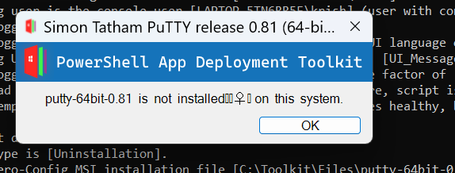

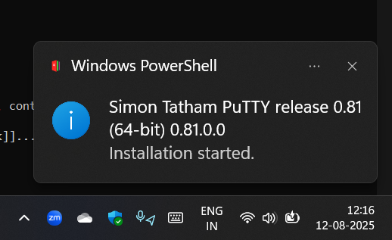

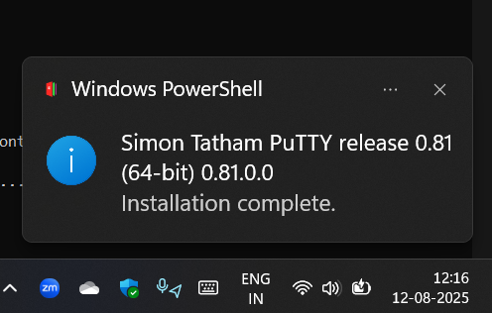

**3. Create Active Setup**

**What it does:** Active Setup is a legacy Windows mechanism to run a command once for every new user who logs on to a computer. The Create-ActiveSetup function automates the process of creating the necessary registry keys and commands for you. This is useful for tasks like creating user-specific shortcuts or installing user-profile components that require a user context.

**When to use it:** Use Create-ActiveSetup when a task needs to be performed for every user on the system, but only a single time per user.

**Practical Screenshots Section :**

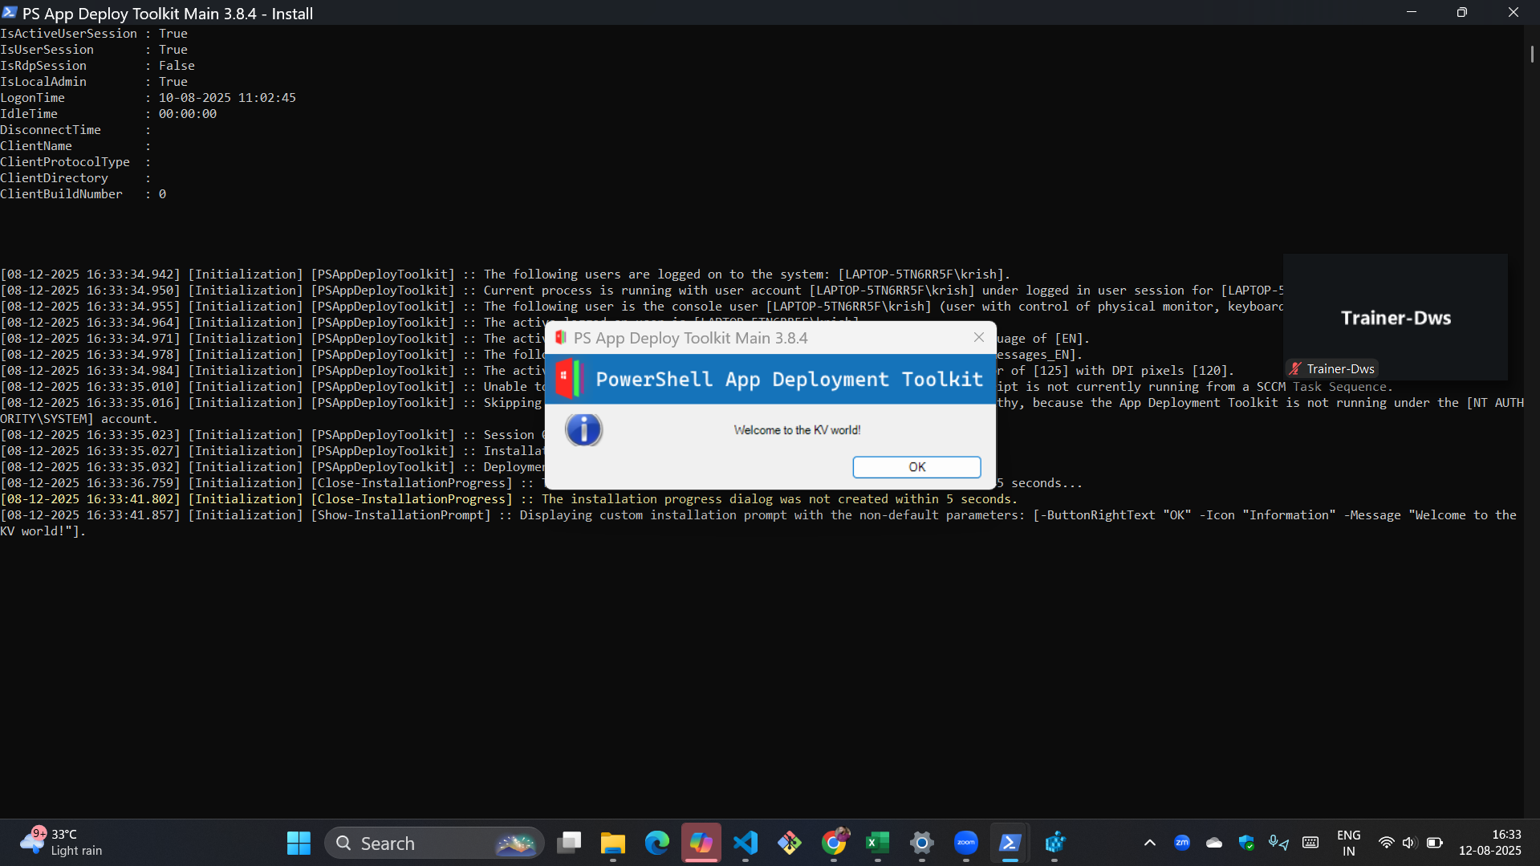

**4. Copy/Delete/Move File and Folders**

**What it does:** PSADT provides a set of wrappers around standard PowerShell commands for file and folder operations. Functions like Copy-File, Remove-File, Copy-Folder, and Remove-Folder are designed to be robust and to log all actions, which is essential for troubleshooting deployments. They also handle wildcards and permissions more gracefully.

**When to use it:** Use these commands to copy additional files (e.g., license files, configuration settings, or supplementary documents), delete leftover files from an uninstallation, or move files to a new location.

**Practical Screenshots Section :**

